

**Fundamentals of programming lab 9**

**Name: Muhammad Amad Naeem**

**CMS ID: 467469**

**Sec: MB-15 B**

**Professor: Affan**

**Task 1:**

**#include<bits/stdc++.h>**

**using namespace std;**

**int main(){**

**int arr[3][3];**

**for(int i=0;i<3;i++){**

**for(int j=0;j<3;j++){**

**cout<<"Enter element "<<i+1<<j+1<<" :";**

**cin>>arr[i][j];**

**cout<<endl;}**

**}**

**int sum1=0;**

**for(int a=0;a<3;a++){**

**for(int k=0;k<3;k++){**

**if (a==k){**

**sum1+=arr[a][k];**

**}**

**else{continue;}**

**}**

**}**

**int sum2=0;**

**for(int b=2;b>=0;b--){**

**for( int c=2; c>=0;c--){**

**if (c==b){**

**sum2+=arr[b][c];}**

**else {continue;}**

**}}**

**int sum= sum1+sum2;**

**cout<<"sum of left and right digonals: "<<sum;**

**return 0;}**

**Output:**

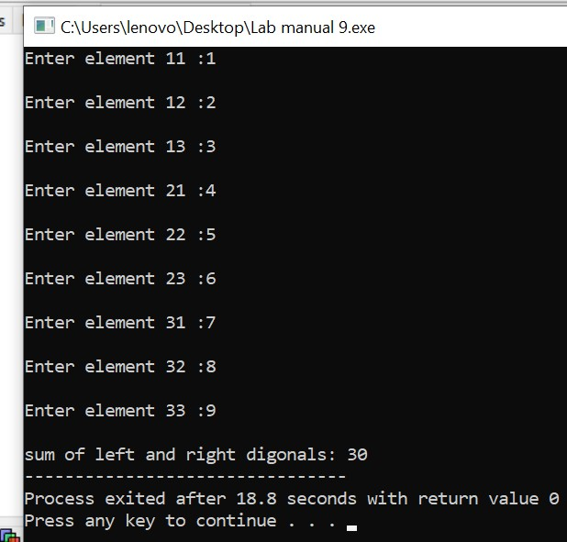

**Task 2:**

**#include<bits/stdc++.h>**

**using namespace std;**

**void func(int matrix1[3][3],int matrix2[3][3],int matrix3[3][3]){**

**for(int x=0;x<3;x++){**

**for(int w=0;w<3;w++){**

**matrix3[x][w]=matrix1[x][w]+matrix2[x][w];**

**}**

**}**

**}**

**int main(){**

**int x=3,w=3;**

**int matrix1[3][3],matrix2[3][3],matrix3[3][3];**

**for(int i=0;i<3;i++){**

**for(int j=0;j<3;j++){**

**cout<<"Enter element "<<i+1<<j+1<<" for 1st martix:";**

**cin>>matrix1[i][j];**

**cout<<endl;**

**}**

**}**

**for(int k=0;k<3;k++){**

**for(int z=0;z<3;z++){**

**cout<<"Enter element "<<k+1<<z+1<<" for 2nd martix:";**

**cin>>matrix2[k][z];**

**cout<<endl;**

**}**

**}**

**func(matrix1,matrix2,matrix3);**

**for(int i=0; i<3; i++){**

**for (int j=0; j<3; j++){**

**cout << matrix3[i][j];**

**}**

**cout << endl;**

**}**

**}**

**Output:**

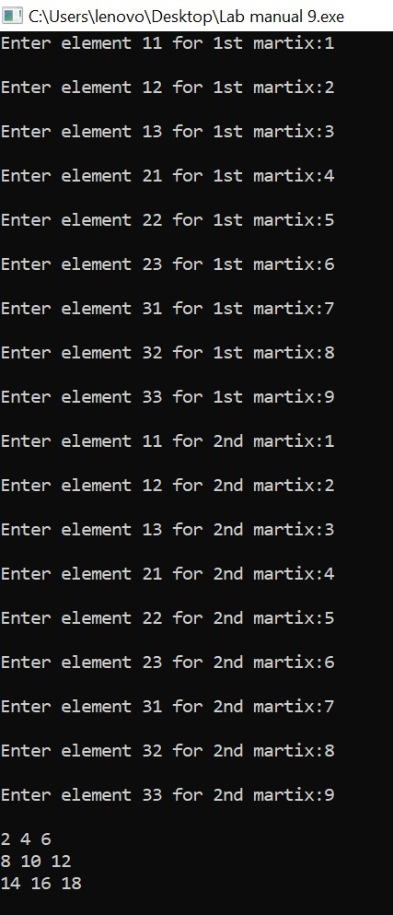

**Task 3:**

**#include<bits/stdc++.h>**

**using namespace std;**

**void func(int mat[3][3],int trans[3][3]){**

**for(int i=0;i<3;i++){**

**for(int j=0;j<3;j++){**

**trans[j][i]=mat[i][j];**

**}**

**}**

**}**

**int main(){**

**int trans[3][3];**

**int mat[3][3];**

**for(int i=0;i<3;i++){**

**for(int j=0;j<3;j++){**

**cout<<"Enter element "<<i+1<<j+1<<" in the matrix: ";**

**cin>>mat[i][j];**

**cout<<endl;**

**}**

**}**

**cout<<"Matrix: "<<endl;**

**for(int i=0;i<3;i++){**

**for(int j=0;j<3;j++){**

**cout<<mat[i][j]<<" ";**

**}**

**cout<<endl;**

**}**

**func(mat,trans);**

**cout<<"Transpose of Matrix: "<<endl;**

**for(int i=0;i<3;i++){**

**for(int j=0;j<3;j++){**

**cout<<trans[i][j]<<" ";**

**}**

**cout<<endl;**

**}**

**Output:**

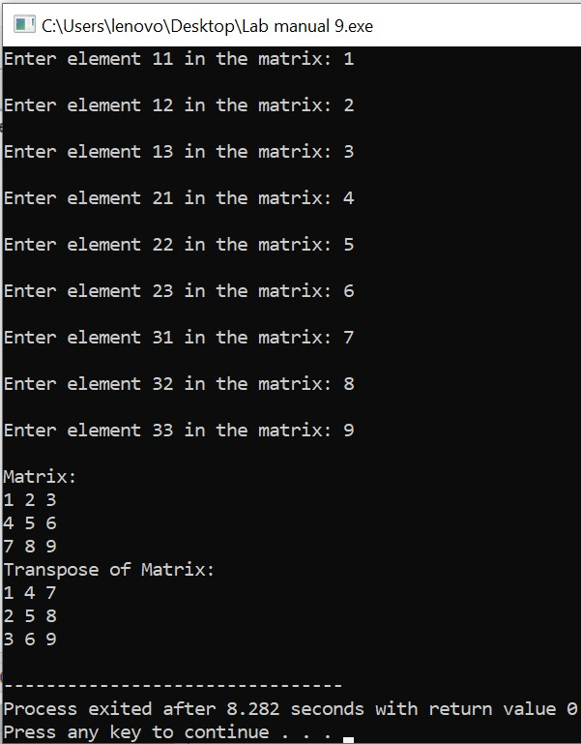

**return 0;}**

**Task 4:**

**#include<bits/stdc++.h>**

**using namespace std;**

**int multiply(int a[3][3], int b[3][3], int ans[3][3]){**

**for(int i=0; i<3; i++){**

**for(int j=0; j<3; j++){**

**for(int k=0; k<3; k++){**

**ans[i][j]+=a[i][k]*b[k][j];**

**}**

**}**

**}**

**}**

**int main(){**

**int a[3][3], b[3][3], ans[3][3]={{0},{0}};**

**cout<<"Input 9 integers for matrix 1: "<<endl;**

**for(int i=0; i<3; i++){**

**for(int j=0; j<3; j++){**

**cin>>a[i][j];**

**}**

**}**

**cout<<"Input 9 integers for matrix 2:"<<endl;**

**for(int i=0; i<3; i++){**

**for(int j=0; j<3; j++){**

**cin>>b[i][j];**

**}**

**}**

**multiply(a, b, ans);**

**cout<<"The product of the two matrix is:"<<endl;**

**for(int i=0; i<3; i++){**

**for(int j=0; j<3; j++){**

**cout<<ans[i][j]<<" ";**

**}**

**cout<<endl;**

**}**

**return 0;**

**}**

**Output:**

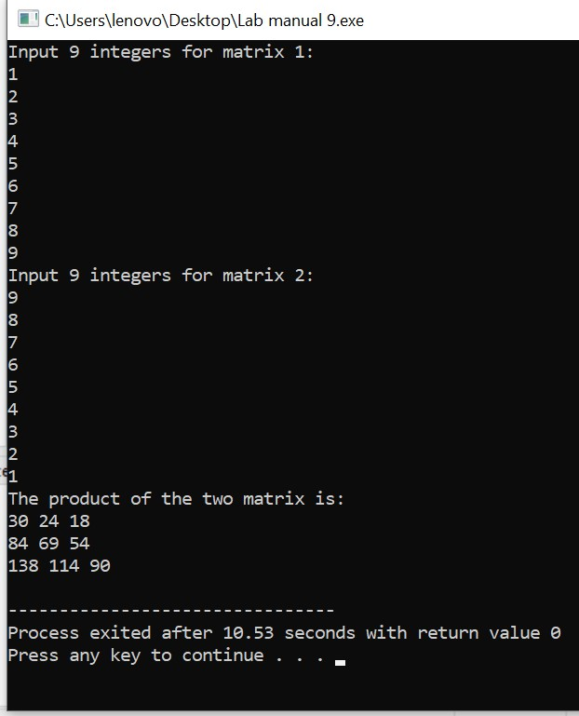

**Task 5:**

**#include<bits/stdc++.h>**

**using namespace std;**

**void table(int num,int i){**

**if(i>10){**

**return ;**

**}**

**cout<<num<<"*"<<i<<" = "<<num*i<<endl;**

**return table(num, i+1);**

**}**

**int main(){**

**int number=0,i,result;**

**cout<<"write the table of: ";**

**cin>>number;**

**cout<<"the table of "<<number<< "is "<<endl;**

**table(number,i);**

**return 0;**

**}**

**Output:**

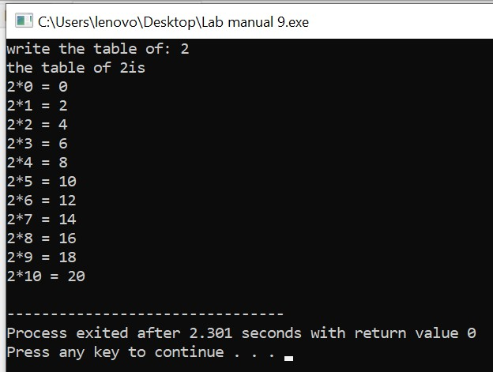

**Home task:**

**#include<iostream>**

**using namespace std;**

**int main(){**

**int mat1[3][3];**

**cout<<"enter the elements in the matrix"<<endl;**

**for(int i=0;i<3;i++){**

**for(int j=0;j<3;j++){**

**cin>>mat1[i][j];**

**}**

**}**

**cout<<"entered matrix is "<<endl;**

**for(int i=0;i<3;i++){**

**for(int j=0;j<3;j++){**

**cout<<mat1[i][j]<<" ";**

**}**

**cout<<endl;**

**}**

**cout<<"the determinant of the matrix is "<<" ";**

**int det=0;**

**for(int i=0;i<3;i++){**

**det=det+mat1[0][i]*(mat1[1][(i+1)%3]*mat1[2][(i+2)%3]-mat1[1][(i+2)%3]*mat1[2][(i+1)%3]);**

**}**

**cout<<det<<endl;**

**cout<<endl;**

**cout<<endl;**

**if(det==0){**

**cout<<"the inverse is not possible because its determinant is zero "<<endl;**

**return 0;**

**}**

**cout<<"adjoint of matrix = "<<endl;**

**for(int i=0;i<3;i++){**

**for(int j=0;j<3;j++){**

**cout<<((mat1[(j+1)%3][(i+1)%3]*mat1[(j+2)%3][(i+2)%3])-(mat1[(j+1)%3][(i+2)%3]*mat1[(j+2)%3][(i+1)%3]))<<" ";**

**}**

**cout<<endl;**

**}**

**cout<<"the inverse of the given matrix is: "<<endl<<endl;**

**for(int i=0;i<3;i++){**

**for(int j=0;j<3;j++){**

**cout<<((mat1[(j+1)%3][(i+1)%3]*mat1[(j+2)%3][(i+2)%3])-(mat1[(j+1)%3][(i+2)%3]*mat1[(j+2)%3][(i+1)%3])/det)<<" ";**

**}**

**cout<<endl;**

**}**

**return 0;**

**}**

**Output:**

